


Lesson 1
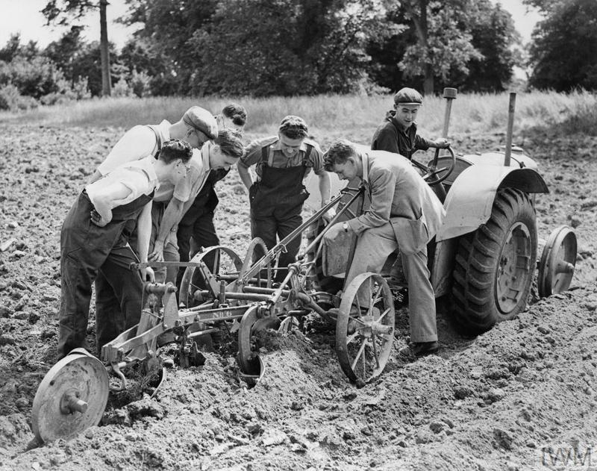
COs and the Second World War
‘Britain’s Home Front, 1939–1945: Conscientious Objectors’. © IWM (HU 36259)

Introduction
During the Second World War, nearly 60,000 men (1 per cent of all men conscripted) and 900 women attested a conscientious objection in Britain. Most conscientious objectors (COs) opposed the war on religious grounds, although many objected due to moral, political, or humanitarian beliefs. Most, but not all, COs were from middle- or upper-class backgrounds. While some were unwilling to work in any capacity which contributed to the national war effort, many COs served in roles deemed to be of ‘national importance’.
The National Service (Armed Services) Act 1939 allowed for men to conscientiously object to military service subject to a successful civilian tribunal. Of the 60,000 men who professed a conscientious objection, 12,204 were rejected outright, while 3,577 were granted complete exemption. Some COs were imprisoned for refusing to engage with the tribunal process, although this was relatively rare (with only 300 men given a prison sentence). In total, 45,000 men were employed in roles which made important, non-military contributions to Britain’s Second World War effort.

Suitable for: KS2 History
Time Period: The Second World War (1939–45)
Curriculum Links: Second World War COs provide an excellent case study covering ‘an aspect or theme in British history that extends pupils’ chronological knowledge beyond 1066’ and ‘a local history study’. In addition, the material supports pupils in developing ‘a chronologically secure knowledge and understanding of British, local and world history’ alongside helping pupils to ‘understand the complexity of people’s lives, the process of change, the diversity of societies and relationships between different groups’.
Learning Objectives: To investigate the lived experiences of British Second World War COs.
Resources Needed: Printed sources and questions; IT room/access to computers to use interactive map.

Suitable for: Scottish Advanced Higher History
Time Period: The Second World War (1939–45)
Curriculum Links: Second World War COs allow ‘candidates [to] develop their understanding of the world by learning about other people and their values, in different times, places and circumstances’. Given the focus on protest and objection to war, the resources and learning materials enable ‘candidates to develop important attitudes including an open mind and respect for the values, beliefs and cultures of others; openness to new thinking and ideas; and a sense of responsibility and global citizenship’. The sources used in the learning material also encourage candidates to ‘engage with a wide range of source material, and to review a wide range of interpretations of history’.
Module Links: The learning material will be of particular interest to those on the module ‘Britain: At War and Peace, 1938–51’, especially as the module explores the socio-economic impact of the conflict domestically. The learning material aligns with many of the themes and issues examined in the module – namely conscription; labour; industrial relations; citizenship; civil-military relations; civil defence; and class (among other issues).
Learning Objectives: To investigate the lived experiences of British Second World War COs.
Resources Needed: Printed sources and questions; IT room/access to computers to use interactive map.

Teacher’s Notes
This lesson explores the lives, experiences, and work of Britain’s Second World War COs. It provides an overview of why COs rejected military service and asks pupils to explore some of the attitudes towards COs. It looks at how professing an objection to war could affect relationships between COs, their friends, and their family members. The lesson also encourages pupils to think about some of the ways in which registering as a CO impacted upon individuals emotionally – particularly in relation to feelings of doubt and uncertainty. As the stories contained within the CO map reveal, COs were mistreated and drew criticism in certain quarters on occasion, but there was far more tolerance towards objectors than in the First World War.

Tasks
Activity 1
Read through the case studies on the CO map on the home page and answer the following questions:
- What are some of the reasons that COs objected to fighting during the Second World War? How many different examples can you find?
- How were COs treated by friends, family members, and in society?
- How were COs treated within the military?
- How did the First World War influence Second World War COs?
- Do you think it would be difficult or easy to be a CO? Explain your answer.
- Was there a particular story that you found interesting or moving? If so, why?
- Did reading about COs add to or change your understanding and knowledge of the Second World War in Britain?

