


Lesson 2
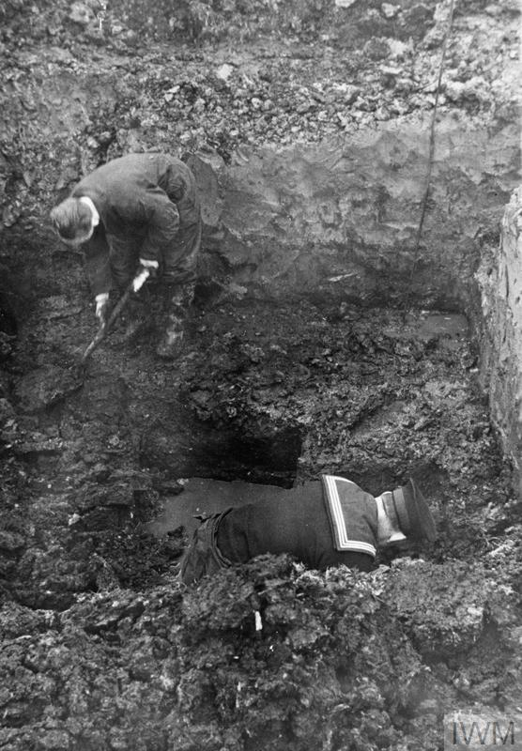
COs and the Home Front

A conscientious objector serving with the Royal Engineers bomb disposal squad and a naval rating during the Second World War. © IWM (HU 58432)
Introduction
Despite objecting to the conduct of war on religious, political, and moral grounds, British COs were involved in a variety of activities on the Home Front during the Second World War. This included passive air defence, bomb disposal, fire watching, agricultural and forestry work, mining, hospital work, and other areas deemed to be of ‘national importance’. A misconception surrounding the role of COs is that they were unwilling to serve in any capacity during the Second World War. Yet, as this lesson demonstrates, they made active contributions to the national war effort. This lesson not only explores the lived experiences of COs on the Home Front during the Second World War, but it also encourages students to think about domestic life and the conduct of war in Britain more generally.

Suitable for: KS2 History
Time Period: The Second World War (1939–45)
Curriculum Links: Second World War COs provide an excellent case study covering ‘an aspect or theme in British history that extends pupils’ chronological knowledge beyond 1066’ and ‘a local history study’. In addition, the material supports pupils in developing ‘a chronologically secure knowledge and understanding of British, local and world history’ alongside helping pupils to ‘understand the complexity of people’s lives, the process of change, the diversity of societies and relationships between different groups’.
Learning Objectives: To investigate the work carried out by British COs on the Home Front.
Resources Needed: Printed sources and questions; IT room/access to computers to use interactive map.

Suitable for: Scottish Advanced Higher History
Time Period: The Second World War (1939–45)
Curriculum Links: Second World War COs allow ‘candidates [to] develop their understanding of the world by learning about other people and their values, in different times, places and circumstances’. Given the focus on protest and objection to war, the resources and learning materials enable ‘candidates to develop important attitudes including an open mind and respect for the values, beliefs and cultures of others; openness to new thinking and ideas; and a sense of responsibility and global citizenship’. The sources used in the learning material also encourage candidates to ‘engage with a wide range of source material, and to review a wide range of interpretations of history’.
Module Links: The learning material will be of particular interest to those on the module ‘Britain: At War and Peace, 1938–51’, especially as the module explores the socio-economic impact of the conflict domestically. The learning material aligns with many of the themes and issues examined in the module – namely conscription; labour; industrial relations; citizenship; civil-military relations; civil defence; and class (among other issues).
Learning Objectives: To investigate the work carried out by British COs on the Home Front.
Resources Needed: Printed sources and questions; IT room/access to computers to use interactive map.

Teacher’s Notes
This lesson asks pupils to develop their understanding of the Second World War Home Front by exploring the lived experiences of British COs. While COs were, on occasion, accused of cowardice or as having shirked their ‘duty’, many made important non-military contributions to the nation. By using the CO map, pupils will examine the work carried out by COs and discover that many objectors were driven by humanitarian impulses and a desire to relieve the suffering caused by war. In doing so, COs were often willing to expose themselves to risk and danger.

Tasks
Activity 1
Read through the case studies on the CO map and answer the following questions:
- What sort of work were COs involved in on the Home Front? How many different examples can you find? Make a list and compare with classmates.
- How did COs help those suffering from the effects of war in Britain?
- Did COs make an important contribution to the national war effort?
- Were COs always satisfied with the work they were carrying out?
- Although COs did not serve in a military capacity, were they ever exposed to risk and danger in their work? If so, what risks did COs face?

