


Lesson 3
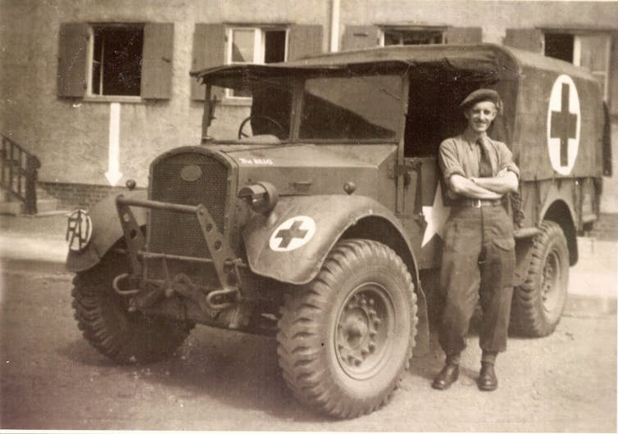
COs and the Second World War beyond Britain
‘Friends Ambulance Unit ambulance driver, with his vehicle in Wolfsburg, Germany’ at the end of the Second World War: Wikimedia Commons/Vernon39

Introduction
Beyond their work in Britain, COs spent time in Norway, Finland, Germany, France, Italy, Greece, Egypt, Palestine, Ethiopia, India, Burma, and China (among other places). Many COs joined bodies such as the Royal Army Medical Corps (RAMC) and the Friends Ambulance Unit (FAU). The RAMC was a long-standing non-combatant body designed to provide medical services and save the lives of men serving in the British Army. COs in the FAU – a re-creation of a First World War voluntary ambulance service established by Quakers – treated both military and civilian casualties on the home front and the battle front. Both the RAMC and FAU were popular choices for humanitarian reasons, with COs serving as medics, ambulance drivers, in blood transfusion units, and in other roles across the globe. In carrying out such work, COs faced significant danger. Indeed, COs were present at some of the key military engagements of the Second World War, including Dunkirk, El Alamein, Monte Casino, and D Day, while others were captured and spent time as prisoners of war.

Suitable for: KS2 History
Time Period: The Second World War (1939–45)
Curriculum Links: Second World War COs provide an excellent case study covering ‘an aspect or theme in British history that extends pupils’ chronological knowledge beyond 1066’. In addition, the material supports pupils in developing ‘a chronologically secure knowledge and understanding of British, local and world history’ alongside helping pupils to ‘understand the complexity of people’s lives, the process of change, the diversity of societies and relationships between different groups’.
Learning Objectives: To investigate the work carried out by British COs on an international level throughout the Second World War.
Resources Needed: Printed sources and questions; IT room/access to computers to use interactive map.

Suitable for: Scottish Advanced Higher History
Time Period: The Second World War (1939–45)
Curriculum Links: Second World War COs allow ‘candidates [to] develop their understanding of the world by learning about other people and their values, in different times, places and circumstances’. Given the focus on protest and objection to war, the resources and learning materials enable ‘candidates to develop important attitudes including an open mind and respect for the values, beliefs and cultures of others; openness to new thinking and ideas; and a sense of responsibility and global citizenship’. The sources used in the learning material also encourage candidates to ‘engage with a wide range of source material, and to review a wide range of interpretations of history’.
Module Links: The learning material will be of particular interest to those on the module ‘Britain: At War and Peace, 1938–51’, especially as the module explores the socio-economic impact of the conflict. The learning material aligns with many of the themes and issues examined in the module – namely conscription; labour; industrial relations; citizenship; civil-military relations; civil defence; and class (among other issues).
Learning Objectives: To investigate the work carried out by British COs on an international level throughout the Second World War.
Resources Needed: Printed sources and questions; IT room/access to computers to use interactive map.

Teacher’s Notes
By using the interactive map on the website, students will explore the rich and diverse experiences of British Second World War COs across the globe. COs worked as teachers in Ethiopia; were involved in humanitarian and relief work in Austria and Germany; served in anti-typhus research units in North Africa and Italy; contributed to the distribution and transport of medical supplies in Burma and China; worked in ambulance units in the evacuation of Dunkirk and on D Day; provided relief at concentration camps such as Bergen-Belsen; and spent time as prisoners of war. In examining these stories, students will gain an understanding of the international activities of British COs throughout the Second World War.

Tasks
Activity 1
Using the CO map, choose one CO that is interesting to you and follow the link to their story on the Imperial War Museum Sound Archive. Read the ‘object’ and ‘content’ description and make a list of all the different places that your CO served during the war. Compare and contrast the experience of your CO with that of your classmates. Are there any similarities between their war experiences? Any differences? Did your CO serve only in Britain or in other places across the world?

Activity 2
Read through the case studies on the CO map and answer the following questions:
- What roles did COs serve in outside Britain during the Second World War?
- What was the Friends Ambulance Unit? Where did men serve while with the FAU?
- What was the Royal Army Medical Corps? Where did men serve while with the RAMC?
- As was the case domestically, men in the FAU and RAMC did not contribute to the war in a military capacity, but were they exposed to danger or risk? What kind?
- Do you think that the work of COs on an international level was important? Explain your answer.
- Can you find any examples of COs being recognised or honoured for their bravery?

