


Lesson 4
Objection, Masculinity, and War
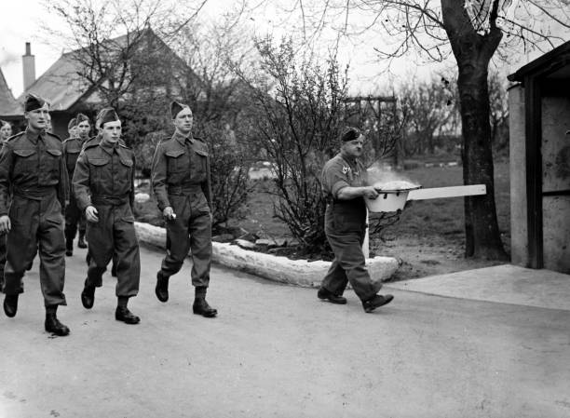

‘British non-combatant COs’, 1940, © Popperfoto/Getty Images

Introduction
During the Second World War, COs drew criticism and were mistreated in certain quarters, but there was far more tolerance towards objectors than in the First World War. Government propaganda used during the 1914–1918 conflict, including slogans such as ‘Men of Britain! Will You Stand This?’ and ‘Daddy what did YOU do in the Great War?’, was not part of the later war. Similarly, the infamous campaign of white feathers, used to point to the supposed cowardice and unmanliness of those out of uniform during the First World War, was also not a widespread feature of the Second World War. Yet, many still felt that young men should be in uniform, willing to fight for their country. This lesson introduces students to some of the pressures faced by COs during the Second World War, while considering questions of manliness and masculinity and how such notions were interpreted in both the First and the Second World Wars.

Suitable for: KS2 History
Time Period: The Second World War (1939–45)
Curriculum Links: Second World War COs provide an excellent case study covering ‘an aspect or theme in British history that extends pupils’ chronological knowledge beyond 1066’ and ‘a local history study’. The material also supports pupils in developing ‘a chronologically secure knowledge and understanding of British, local and world history’ alongside helping pupils to ‘understand the complexity of people’s lives, the process of change, the diversity of societies and relationships between different groups’. In addition, this lesson will allow pupils to address and devise ‘historically valid questions about change, cause, similarity and difference, and significance’.
Learning Objectives: To investigate the lived experiences of Second World War British COs; to examine questions of manliness and masculinity during war.
Resources Needed: Printed sources and questions; IT room/access to computers to use interactive map.

Suitable for: Scottish Advanced Higher History
Time Period: The Second World War (1939–45)
Curriculum Links: Second World War COs allow ‘candidates [to] develop their understanding of the world by learning about other people and their values, in different times, places and circumstances’. Given the focus on protest and objection to war, the resources and learning materials enable ‘candidates to develop important attitudes including an open mind and respect for the values, beliefs and cultures of others; openness to new thinking and ideas; and a sense of responsibility and global citizenship’. The sources used in the learning material also encourage candidates to ‘engage with a wide range of source material, and to review a wide range of interpretations of history’.
Module Links: The learning material will be of particular interest to those on the module ‘Britain: At War and Peace, 1938–51’, especially as the module explores the socio-economic impact of the conflict domestically. The learning material aligns with many of the themes and issues examined in the module – namely conscription; labour; industrial relations; citizenship; civil-military relations; civil defence; and class (among other issues).
Learning Objectives: To investigate the lived experiences of Second World War British COs; to examine questions of manliness and masculinity during war.
Resources Needed: Printed sources and questions; IT room/access to computers to use interactive map.

Teacher’s Notes
This lesson explores questions of manliness and masculinity during war through the lens of COs. In doing so, it uses a range of visual and written sources, as well as oral testimonies. It highlights that, while COs may not have conformed to traditional ideals of bravery, duty, and masculinity, many objectors undoubtedly displayed such virtues. More broadly, by exploring such issues, the lesson points to some of the similarities and differences between societal and governmental attitudes towards objectors in the First and Second World Wars.

Tasks
Activity 1
Consider the images and text below and answer the following questions:
- What do the images show? Why do you think they were created?
- What do the images and text tell us about ideas of duty, bravery, and masculinity in war?
- What impact might such propaganda have on a) conscientious objectors and b) British society more broadly?
- What do the images and text tell us about attitudes towards COs during the Second World War compared to the First World War? Were there any similarities?

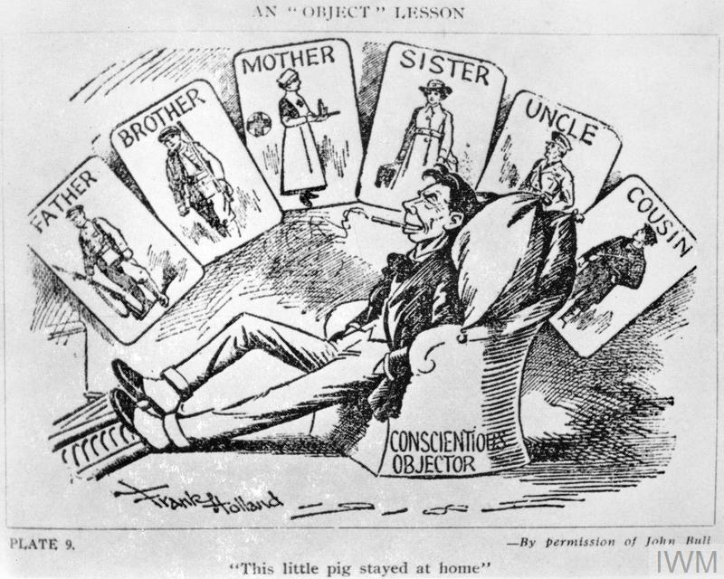

Frank Holland, ‘An “Object” Lesson’, 1914–1918, Image: IWM (Q 103334)
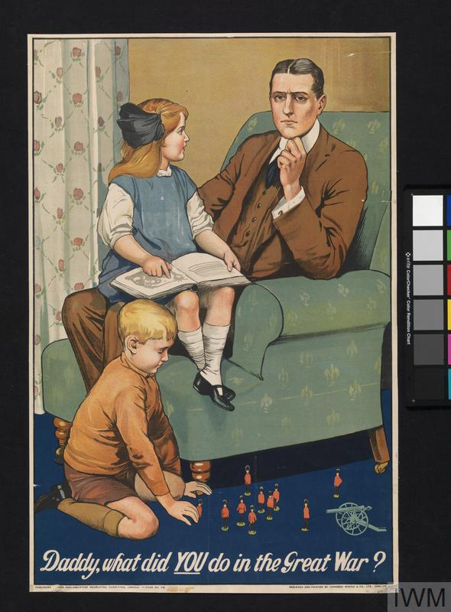

‘Daddy, what did YOU do in the Great War?’, Parliamentary Recruiting Committee Poster No. 79, 1915: Image: IWM (Art.IWM PST 0311)
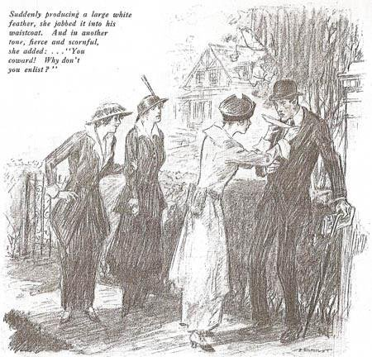

Arnold Bennett, ‘The White Feather: A Sketch of English Recruiting’, Collier’s Weekly, 10 October 1914
- The Military Training Act of 1939, which introduced limited conscription (for men aged 20–21), allowed men to object to military service on the grounds of conscience. During the second reading of the bill in parliament, the Prime Minister Neville Chamberlain stated: ‘I want to make it clear here that in the view of the Government, where scruples are conscientiously held we desire that they should be respected and that there should be no persecution of those who hold them’. Hansard, Military Training Bill, House of Commons Debate, 4 May 1939. https://hansard.parliament.uk/commons/1939-05-04/debates/91243799-b97f-46da-b8d7-4bbaa998b262/MilitaryTrainingBill

- In 1941, Winston Churchill, Chamberlain’s successor as wartime prime minister, said of COs that ‘the rights which have been granted in this war and the last to conscientious objectors are well-known, and are a definite part of British policy. Anything in the nature of persecution, victimisation, or man-hunting is odious to the British people.’ Hansard, Broadcasting Policy, House of Commons Debate, 20 March 1941. https://hansard.parliament.uk/commons/1941-03-20/debates/3b3825c0-8fad-4cab-ac55-1e857a6513d0/BroadcastingPolicy(ArtistesAndTechnicians)

- In an interview with the Imperial War Museum in the late 1980s, Ronald Petts – civilian artist and Second World War CO – recalled that, during the war, ‘I was never presented with a white feather (like First World War COs). I was never spat upon.’ He did, however, note that as he lived in Wales ‘there wasn’t this Union Jack feeling of the British Empire and so on’. https://www.iwm.org.uk/collections/item/object/80009517

- Paul Clark Eddington, an actor and CO during the Second World War, similarly suggested that ‘people were much more grown-up and tolerant in World War Two, I’m quite sure’. https://www.iwm.org.uk/collections/item/object/80009117

- Sydney Wallace, a British NCO who served in Normandy and Palestine, emphasised of Second World War COs that ‘I always have felt they were braver men than I am. Much. Because they’ve got the guts, they’ve got the courage of their convictions to say ‘I don’t want to kill.’’ https://www.iwm.org.uk/collections/item/object/80012819

- Nevertheless, COs still faced animosity on occasion (even within their own family). Tom Haley, a CO and member of the FAU, was told by his father that ‘If you are not prepared to shed a drop of blood in the defence of your mother and sisters, there is no reason why you should be allowed to share their roof’. https://www.iwm.org.uk/collections/item/object/80009924

