


Lesson 6
Commemoration and Conscientious Objection
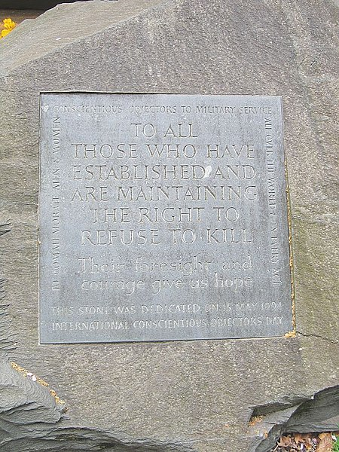

Wikimedia Commons
Introduction
While the Second World War forms an important part of British culture and popular memory to this day, conscientious objectors are almost entirely absent from official, institutional commemorations of the conflict. In some respects, this is rather curious. Almost 60,000 COs served in various capacities across both Britain and beyond and made important non-military contributions to the national war effort. However, the CO is largely at odds with popular British conceptions of the Second World War as a ‘good’ and ‘just’ war. Despite this, a range of individuals, activists, and anti-war groups have established a diverse set of remembrance practices to commemorate the role played by COs during the Second World War. This lesson explores increasing calls for objectors to be included in the commemoration of the 1939–1945 conflict and some of the initiatives which have been established to remember those who refused to fight.

Suitable for: KS2 History
Time Period: The Second World War (1939–45)
Curriculum Links: Second World War COs provide an excellent case study covering ‘an aspect or theme in British history that extends pupils’ chronological knowledge beyond 1066’ and ‘a local history study’. In addition, the material supports pupils in developing ‘a chronologically secure knowledge and understanding of British, local and world history’ alongside helping pupils to ‘understand the complexity of people’s lives, the process of change, the diversity of societies and relationships between different groups’.
Learning Objectives: To investigate the legacies and commemoration of British Second World War COs.
Resources Needed: Printed sources and questions; IT room/access to computers to use interactive map.

Suitable for: Scottish Advanced Higher History
Time Period: The Second World War (1939–45)
Curriculum Links: Second World War COs allow ‘candidates [to] develop their understanding of the world by learning about other people and their values, in different times, places and circumstances’. Given the focus on protest and objection to war, the resources and learning materials enable ‘candidates to develop important attitudes including an open mind and respect for the values, beliefs and cultures of others; openness to new thinking and ideas; and a sense of responsibility and global citizenship’. The sources used in the learning material also encourage candidates to ‘engage with a wide range of source material, and to review a wide range of interpretations of history’.
Module Links: The learning material will be of particular interest to those on the module ‘Britain: At War and Peace, 1938–51’, especially as the module explores the socio-economic impact of the conflict domestically. The learning material aligns with many of the themes and issues examined in the module – namely conscription; labour; industrial relations; citizenship; civil-military relations; civil defence; and class (among other issues).
Learning Objectives: To investigate the legacies and commemoration of British Second World War COs.
Resources Needed: Printed sources and questions; IT room/access to computers to use interactive map.

Teacher’s Notes
This lesson explores the ways in which conscientious objectors have been commemorated and memorialised since 1945. Despite numbering nearly 60,000 men, many of whom served both near the front lines and in important wartime industries and services in Britain, the CO is largely absent in the popular narrative of the Second World War and official commemorations of the conflict. This lesson encourages pupils to think about remembrance practices surrounding the Second World War in Britain and to investigate why COs might be absent from popular forms of commemoration.

Tasks

Activity 1
Read the following articles on The Guardian and BBC websites:
https://www.theguardian.com/commentisfree/2014/nov/09/remembrance-sunday-fought-war
https://www.bbc.co.uk/news/uk-scotland-46137874
Answer the following questions:
- What do the articles say about remembrance and the commemoration of war in Britain?
- Do you think that COs should be commemorated in anniversaries of the Second World War? Explain your answer.
- Are pacifist or anti-war voices part of mainstream remembrance practices in Britain? If not, why do you think that is?
- Why might commemorating COs be considered controversial?

Activity 2
While COs are not officially recognised on Remembrance Sunday, there have been broader attempts to commemorate the CO.
The images below show the Conscientious Objectors’ Commemorative Stone in Tavistock Square, London. Established by the Peace Pledge Union in 1994, the CO stone is one of the few memorials that have been created to commemorate conscientious objection. Ceremonies are held annually at the CO stone on Remembrance Sunday and on International Conscientious Objectors’ Day – a day held to commemorate those who have refused to bear arms and participate in war, both throughout history and today.
Look at the images below and answer the following questions:
- What does the inscription say?
- Why do you think the CO stone might have been established?
- Do you think it is an effective memorial?
- How does it compare to memorials commemorating war and those who died while serving in the military during conflict in Britain? What are some of the similarities and differences?
- How would you choose to commemorate COs? A monument, memorial, or something else? Explain your answer.
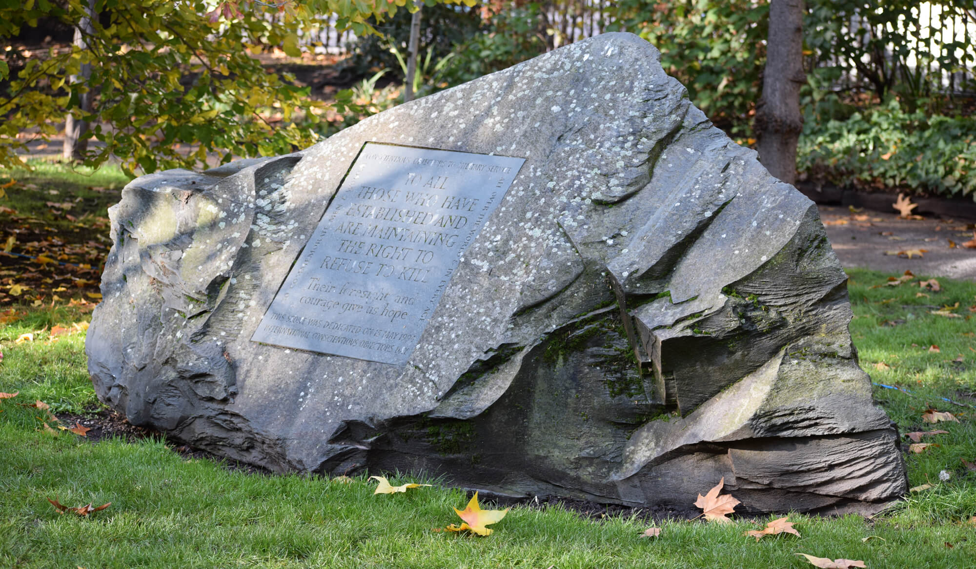
‘Conscientious Objectors’ Commemorative Stone, Tavistock Square, Bloomsbury, London, UK’: https://www.ppu.org.uk/remembrance/conscientious-objectors-commemorative-stone

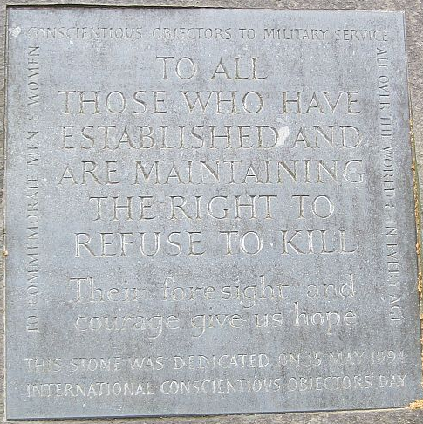
Wikimedia Commons

