


Lesson 7
Tribunals
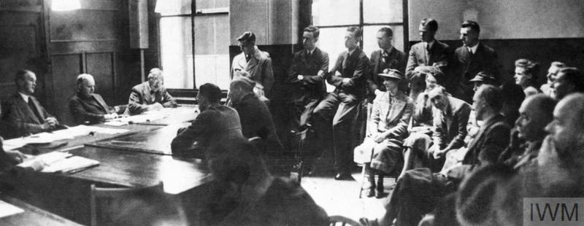
‘Britain’s Home Front, 1939–1945: Conscientious Objector Tribunal’. Image: IWM (HU 62359)
Introduction
The National Service (Armed Services) Act 1939 allowed for men to conscientiously object to military service subject to a successful civilian tribunal. Tribunal panels comprised a county court judge, or a sheriff in Scotland, as chairman and four other members, one of whom was appointed in conjunction with a trade union. Most of the 15 local tribunal panels across Britain held a university academic, alongside doctors, solicitors, barristers, accountants, and others from middle-class professions.
Each potential objector was required to attend a local tribunal to provide a statement outlining their reasons for objecting to the war. Each individual was entitled to in-person testimony or written statements in support of their case. They were then either turned down entirely, given complete exemption, directed to work deemed to be of ‘national importance’, or directed to serve in civilian roles.
Some faced hostility during their tribunals. Ernest Edward Beavor, a Jehovah’s Witness and press photographer before the outbreak of war, was one such CO. After being called up for military service, he refused a medical and so was sent to a tribunal hearing. While there, he was told by the judge, whom Beavor considered ‘intolerant’, that he was the ‘worst of his kind’ and was given a prison sentence which he served in Wormwood Scrubs prison. While prison sentences were relatively rare, 300 men were nevertheless imprisoned for refusing to engage with the tribunal process. For the most part, however, tribunals were far more tolerant, with some COs stating that they were treated with ‘courtesy and respect’. Despite this, tribunals remained a daunting prospect for potential objectors.

Suitable for: KS2 History
Time Period: The Second World War (1939–45)
Curriculum Links: Second World War COs provide an excellent case study covering ‘an aspect or theme in British history that extends pupils’ chronological knowledge beyond 1066’ and ‘a local history study’. In addition, the material supports pupils in developing ‘a chronologically secure knowledge and understanding of British, local and world history’ alongside helping pupils to ‘understand the complexity of people’s lives, the process of change, the diversity of societies and relationships between different groups’.
Learning Objectives: To investigate the lived experiences of Second World War British COs.
Resources Needed: Printed sources and questions; IT room/access to computers to use interactive map.

Suitable for: Scottish Advanced Higher History
Time Period: The Second World War (1939–45)
Curriculum Links: Second World War COs allow ‘candidates [to] develop their understanding of the world by learning about other people and their values, in different times, places and circumstances’. Given the focus on protest and objection to war, the resources and learning materials enable ‘candidates to develop important attitudes including an open mind and respect for the values, beliefs and cultures of others; openness to new thinking and ideas; and a sense of responsibility and global citizenship’. The sources used in the learning material also encourage candidates to ‘engage with a wide range of source material, and to review a wide range of interpretations of history’.
Module Links: The learning material will be of particular interest to those on the module ‘Britain: At War and Peace, 1938–51’, especially as the module explores the socio-economic impact of the conflict domestically. The learning material aligns with many of the themes and issues examined in the module – namely conscription; labour; industrial relations; citizenship; civil-military relations; civil defence; and class (among other issues).
Learning Objectives: To investigate the lived experiences of Second World War British COs.
Resources Needed: Printed sources and questions; IT room/access to computers to use interactive map.

Teacher’s Notes
This lesson introduces students to the structures and processes faced by individuals who wished to declare as a conscientious objector during the Second World War. In particular, it focuses on tribunals and the experiences of those who had to make their case before a tribunal panel. More broadly, the lesson encourages pupils to think about some of the pressures facing COs alongside some of the attitudes towards, and (mis)treatment of, COs.
Teachers should use the introduction section of this lesson plan to familiarise students with the idea of military tribunals, before completing the activity below.

Tasks
Activity 1
Imagine yourself as a potential objector facing a tribunal during the Second World War:
- How would you feel knowing you had to make your case before a tribunal?
- How would you prepare for your tribunal?
- What reasons would you give for objecting to war?
- What area of (non-military) work would you like to serve in?
- Would you want to serve in Britain or abroad during the war? Explain your answer.
- Why do you think some COs were rejected?

