


Lesson 8
Doubt and Uncertainty in the Second World War
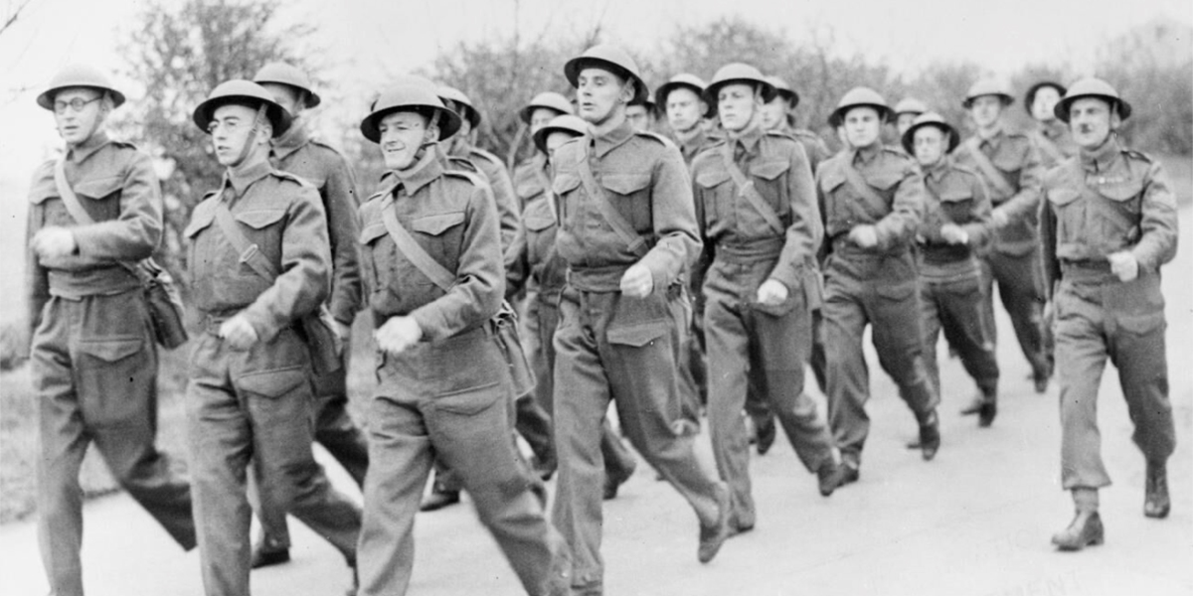
‘Britain’s Home Front, 1939–1945: Non-Combatant Corps’. © IWM (HU 36258)
Introduction
The decision to declare as a conscientious objector during the Second World War led to doubt, uncertainty, guilt, and a range of other emotions. While many COs made important non-military contributions to the nation – and although many COs worked in roles which relieved the suffering caused by war both in Britain and beyond – COs were often plagued with feelings of doubt. This was particularly so given that the conflict was often conceived of as a ‘good’ and ‘just’ war against fascism, even before the Nazi atrocities came to light.
While some COs were convinced that their decision to object to the war on moral, religious, and political grounds was the right course, others were conflicted about their position even long after the war ended. As the interviews used in the CO map and in this lesson reveal, COs still felt uncertainty surrounding their role in the Second World War even decades later.

Suitable for: KS2 History
Time Period: The Second World War (1939–45)
Curriculum Links: Second World War COs provide an excellent case study covering ‘an aspect or theme in British history that extends pupils’ chronological knowledge beyond 1066’ and ‘a local history study’. In addition, the material supports pupils in developing ‘a chronologically secure knowledge and understanding of British, local and world history’ alongside helping pupils to ‘understand the complexity of people’s lives, the process of change, the diversity of societies and relationships between different groups’.
Learning Objectives: To investigate the lived experiences of Second World War British COs; to understand the various ways in which COs responded to war.
Resources Needed: Printed sources and questions; IT room/access to computers to use interactive map.

Suitable for: Scottish Advanced Higher History
Time Period: The Second World War (1939–45)
Curriculum Links: Second World War COs allow ‘candidates [to] develop their understanding of the world by learning about other people and their values, in different times, places and circumstances’. Given the focus on protest and objection to war, the resources and learning materials enable ‘candidates to develop important attitudes including an open mind and respect for the values, beliefs and cultures of others; openness to new thinking and ideas; and a sense of responsibility and global citizenship’. The sources used in the learning material also encourages candidates to ‘engage with a wide range of source material, and to review a wide range of interpretations of history’.
Module Links: The learning material will be of particular interest to those on the module ‘Britain: At War and Peace, 1938–51’, especially as the module explores the socio-economic impact of the conflict domestically. The learning material aligns with many of the themes and issues examined in the module – namely conscription; labour; industrial relations; citizenship; civil-military relations; civil defence; and class (among other issues).
Learning Objectives: To investigate the lived experiences of Second World War British COs; to understand the various ways in which COs responded to war.
Resources Needed: Printed sources and questions; IT room/access to computers to use interactive map.

Teacher’s Notes
This lesson looks at the ways in which COs responded to the Second World War. Rather than focusing on themes such as pride, patriotism, or national identity, the lesson explores the moral and ethical dilemmas faced by objectors, alongside some of the familial, societal, and internal pressures placed on COs to make a military contribution to the nation’s war effort. In examining such issues, the lesson introduces students to many of the anxieties, doubts, and uncertainties felt by COs during the Second World War. Conversely, it also shows that many COs had the support of friends and families, while many (despite external pressures) remained steadfast in their objection throughout the conflict.

Tasks
Activity 1
Using the CO map on the home page and the sources below, answer the following questions:
- What are some of the reasons which might have caused a CO to doubt their objection to war?
- Were feelings of guilt and uncertainty common among COs?
- What are some of the factors which might have helped COs to feel less doubt about their opposition to war?

- Tony Parker, a CO who grew up in Manchester before working at Bradford Colliery during the Second World War, recalled in later life that: ‘All the time one was saying am I doing right or am I doing wrong. Ought I to rethink this? Especially if you had a friend who was killed or injured in the war, that was the time you really felt rather bad about it, rather guilty about it.’ https://www.iwm.org.uk/collections/item/object/80009024

- Raymond Finch, a CO who was working at a pottery in Winchcombe at the outbreak of war, similarly recalled ‘I had a big big struggle about that not so much about letting the country down because I didn’t think it would make much difference whether I was in the army or not but I felt I was letting people like [his friends] Sid and Charlie down you know, who were called up fairly quickly. People I knew. My brother in law was in the forces. And that sort of thing weighed quite heavily.’ – British Library Sounds, National Life Stories: Crafts Lives, Raymond Finch, C960/18

- Dennis Allen, an absolutist CO, felt that ‘For me to be a pacifist in the Second World War was a far more difficult decision to take than it would have been in the First World War which was an entirely imperial business between Germany and Britain and the other allies. The Second World was different in kind … It was a difficult decision to take.’ Ultimately, however, he ‘decided that the religious duty to preserve life and to love one’s enemies really superseded all consequences’. https://www.iwm.org.uk/collections/item/object/80011270

- Others, such as John Eryl Hall-Williams, had less uncertainty: ‘I think I was so determined that war was not the answer and at that time, and even now, believed that we should not rearm and we should not drop bombs. But I had very little consciousness of the consequences of that. The suffering that was going on in Europe only became evident later.’ https://www.iwm.org.uk/collections/item/object/80014863

- Paul Clark Eddington stated that he ‘didn’t have a great deal of support’ generally in his status as a CO ‘Apart, of course, from my family. More particularly from my mother and her circle. And the support there was solid and unquestioning. And that’s all I needed.’ https://www.iwm.org.uk/collections/item/object/80009117

- Michael Rowntree, member of the Friends Ambulance Unit and Hadfield-Spears Unit, later noted that the most positive thing about his time with the FAU was the ‘camaraderie that existed, the friendships we made and have lasted in most cases ever since’. William Brough, fellow member of the FAU, similarly stated: ‘We needed each other. We needed the confirmation of each other. We needed the affirmation of each other.’ https://www.iwm.org.uk/collections/item/object/80010660; https://www.iwm.org.uk/collections/item/object/80011838

Activity 2
Imagine you are a CO and the Second World War has just been declared. Write a short diary entry attempting to capture your feelings towards the outbreak of war and some of your doubts and concerns about the conflict. Are you worried about what your role in the war will be or how you might be treated by friends, family, and members of the public? Compare your diary entries with classmates to see if there are any similarities/differences.

